Website Planning

**The Mountain Spoke**

Tyler Anderson

**Site Purpose:**

The Mountain Spoke website provides information about our premium, high-quality bicycle shop that specializes in selling, and repairing bicycles and bicycle parts. In addition, we off bicycle enthusiasts from around the world an easy access to information about the organized, guided tours made by us.

**Target Audience:**

Avid and enthusiast cyclists. Anyone and everyone who wants to ride a bicycle or those looking for a high-quality repair job. From leisure cyclists who want to enjoy the summer breeze, to the die-hard, dedicated cyclists who love a good challenge.

**Site map**:

Home

Contact

Service

Thank You

Events

Sales

Tours

404

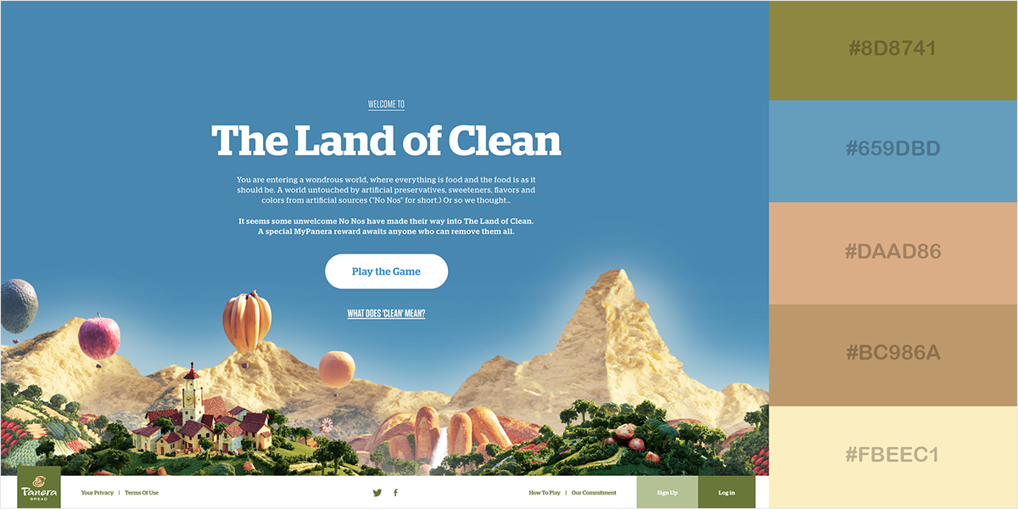**Color Scheme:**

Logo will have brown and blue.

Background will have a light grey color.

Accents will be mixed with greens and browns.

Section backgrounds will be more of a skin/peach color

**Typography**

Poppins Font

**Layout: Large**

Logo – Current Page

Nav Bar

Side Bar seamlessly merges with nav.

Mountain biker - Img

Latest Tour News

***Learn More!***

Repair? No problem!

Click here!

Need a new bike?

See Selection!

Displays bikes for sale.

Advertisement

Footer – Contact Info

Info about last tour

Medium

Logo - Current Page

Nav Bar

Mountain biker - Img

Latest Tour News

***Learn More!***

Advertisement

Displays bikes for sale.

Repair? No problem!

Click here!

Need a new bike?

See Selection!

Footer – Contact Info

Footer

Info about last tour

Small

Logo - Current Page

Hamburgler

Mountain biker - Img

Need a new bike?

See Selection!

Nav Bar slides in from the right

Repair? No problem!

Click here!

Info about last tour

Footer